
Sunday AM Sermon – July 10, 2022
COVID Grief and the Disciple of Jesus
Philippians 1:21-27

What is that nagging feeling I’ve had since COVID struck that doesn’t seem to go away? Have you wondered that? It may show up in different ways in different people, but it’s most likely grief. And it’s a grief that we can do something about.

1. Mark the number of times you hear these words:
Grief –
COVID –
Loss(es) –

2. What was C. S. surprised to find that grief felt like?

3. What are some changes and losses people have experienced during COVID?

4. What are some surprising ways that grief might show up during COVID?

5. Action #1: ___________ __________

6. What is the standard advice from mental health experts about major losses?

7. Action #2: __________ Yourself to __________ and _________

8. What danger is there with our emotions during COVID?

9. Action #3: Be __________ and __________ about your __________

10. What are some decisions people might regret from COVID?

11. In order to avoid or alleviate regret, what do we need to do instead?

12. Action #4: _________ God __________ you

13. What do tests of faith reveal?

14. Action #5: _________ on to what is __________ and ___________ God for it
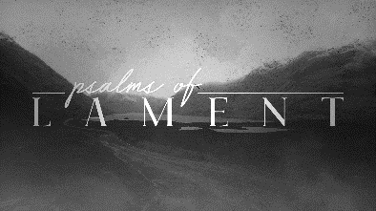
15. What happened at the end of nearly every lament psalm?

16. According to Cloud and Townsend, what is the pain that heals all others?
Faith Talk, Faith Walk
Spend time with family or friends (maybe over a meal or during a family devotional) discussing the following related to the sermon

Faith Talk: What during Jesus’ Passion Week most captures your attention and why?
Faith Walk: Embrace the gospel of the death, burial and resurrection of Jesus, and be ready to share it.
If you are here and have been touched or convicted by something said or done today we would love to study the Bible with you and introduce you more fully to our Savior, Jesus Christ. Just call the church office at 795-4377 and we will set something up. God bless you!
Next Sunday AM Sermon – Why Another Book? (Ecclesiastes 12:9-14)

